**FALL TRAINING CONFERENCE 2017**

**Registration Guide**

TABLE OF CONTENTS:

THINGS TO KNOW 2

WAITLIST POLICY 3

REGISTRATION INSTRUCTIONS 4-8

RESOURCES 8

FREQUENTLY ASKED QUESTIONS 9

CHECKLIST 10

DRIVER REMINDERS 10

FTC CONTACTS 11

**DEADLINES:**

**Early Registration:** Register online by **Thursday, October 12, 2017** at *$145* per person

**Late Registration:** Register online after October 12, 2017 but before **Thursday, October 19, 2017** at *$170* per person

Note: Payment (check), a copy of your FTC email confirmation page, and a completed waiver and code of conduct form for each member must be **RECEIVED** in the District office (NOT sent/postmarked) by the early or late registration deadline.

**Cal-Nev-Ha Kiwanis District Office**

**8360 Red Oak Street, Suite 201**

**Rancho Cucamonga, CA, 91730**

**THINGS TO KNOW**

1. The club president or an assigned board member should be the **ONLY** person to register for the entire club.
2. Please gather all of the necessary information of all of your FTC attendees and fill out the provided Excel spreadsheet before registering online. There is a set limit of *30* minutes for the usage of the website. The necessary information includes:

* Name, email address, gender
* Current club office held
* Food allergies
* Vegetarian or gluten-free meal (Y/N)
* New member (Y/N)
* T-Shirt size

1. You will be required to submit a separate Sergeant-At-Arms volunteer form (can be found on the website; priority registration due **Friday, October 13, 2017,** final registration due **Friday, October 20, 2017**), and this Google form for your club’s ride arrangements (<https://goo.gl/forms/iVf0FTB8tHIwOJEW2>; due **Tuesday, October 31, 2017**).
2. We only accept a check as payment for registration fees. No credit card payment will be accepted. Please submit only **ONE** check to the District Office, made payable to **Cal-Nev-Ha Circle K**.
3. Waiver and Code of Conduct forms must be turned in with the payment!!
4. Members who are attending Fall Training Conference must be **DUES-PAID**. Be sure all attending members are officially registered by the start of the conference.
5. Each club is automatically allocated space for **20 individuals** (not including members serving on the FTC committee or the District Board). Please refer to the waitlist policy if you have more than 20 members interested.
6. No changes may be made to your registration once you complete the online registration process. If you need to make any changes, such as name changes, please email changes to Bruce Hennings at [bruce@cnhkiwanis.org](mailto:bruce@cnhkiwanis.org) by **October 19, 2017**. No additional attendees may be added after October 19, 2017.
7. The conference registration price is per person and includes conference souvenirs, a conference t-shirt and the following meals: breakfast, lunch and dinner on Saturday and breakfast on Sunday.

**WAITLIST POLICY**

* Every club should register and submit payment for **ALL** members who are committed to attend FTC.
* The first 20 names submitted per club will be allocated a spot at FTC. This number does NOT include any District Board members, the Subregion B Trustee, any International representative from outside the CNH District, recognized members of the FTC Committee, or advisors (Faculty and Kiwanis).
* Any number beyond the allocated 20 spots will be placed on a waitlist.
* Members must register with their home club (e.g., members of UCLA Circle K may not be registered under USC Circle K.)
* All registered members, waitlist or not, must be dues-paid members of Circle K International.
* After the registration deadline passes, we can then determine how many people on the waitlist we can accommodate and contact the clubs accordingly.
* In the case that we are unable to accommodate anyone on the waitlist, full refunds will be issued.
* Clubs CANNOT register additional attendees after registration closes, even if the general capacity is not reached.

**Cancellation** must be submitted in writing by emailing Bruce Hennings at bruce@cnhkiwanis.org by **October 19, 2017**. There will be a *$10* process fee per cancelled registration.

**To Swap Members WITHIN the Same Club**:

A club may exchange members by emailing Bruce at bruce@cnhkiwanis.org. Please list and specify the names of both the member dropping out and the member that will be replacing him/her. Name exchanges must be submitted before **October 19, 2017**. Last-minute exchanges thereafter may only be made due to emergencies, and may only be made with the same gender from the same club because the camp requires each cabin to be limited by gender, and the housing assignments will have already been arranged.

**REGISTRATION INSTRUCTIONS**

If you are ready to begin, please click on the registration website: [https://KiwanisCNHFoundation.formstack.com/forms/ckftc](https://kiwaniscnhfoundation.formstack.com/forms/ckftc)

**PART 1**:

Read the Governor’s welcome by Lawrence Sahagun, then press “Next >>”.

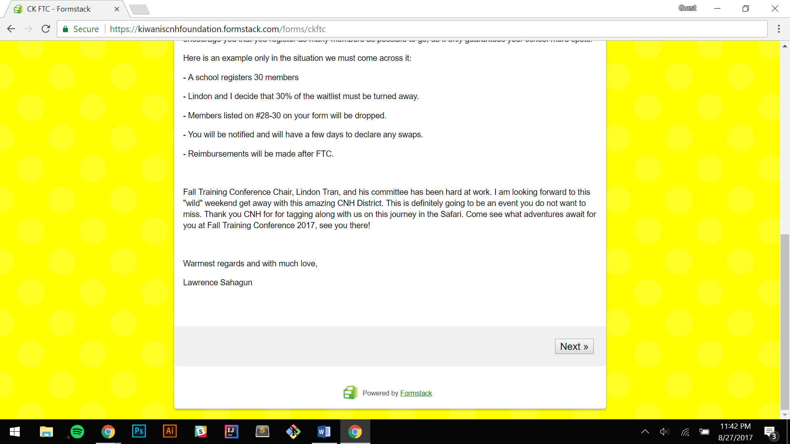

**PART 2**:

Read the things to know and download the Excel template!!

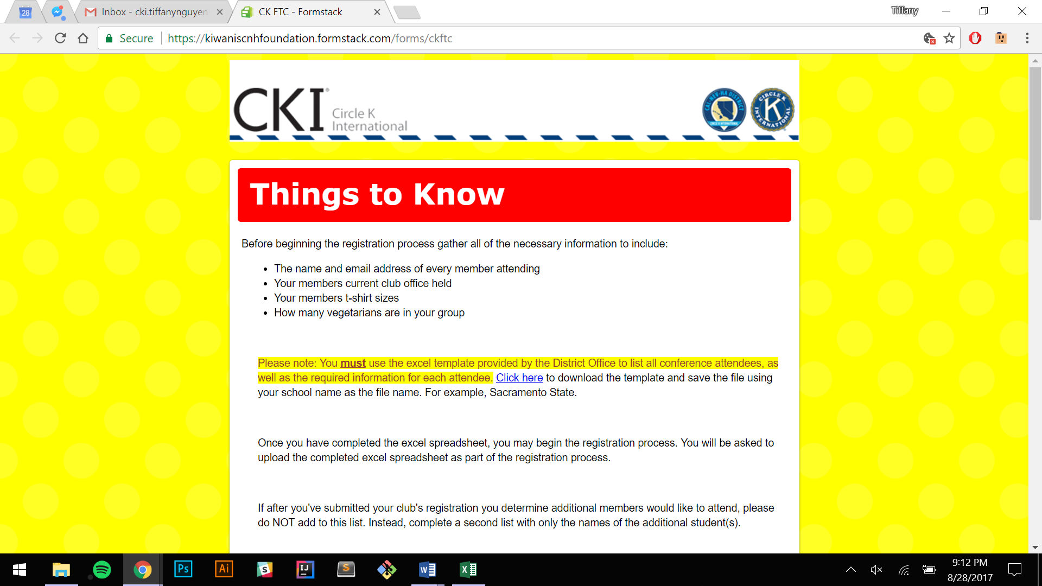

Within the Excel Sheet:

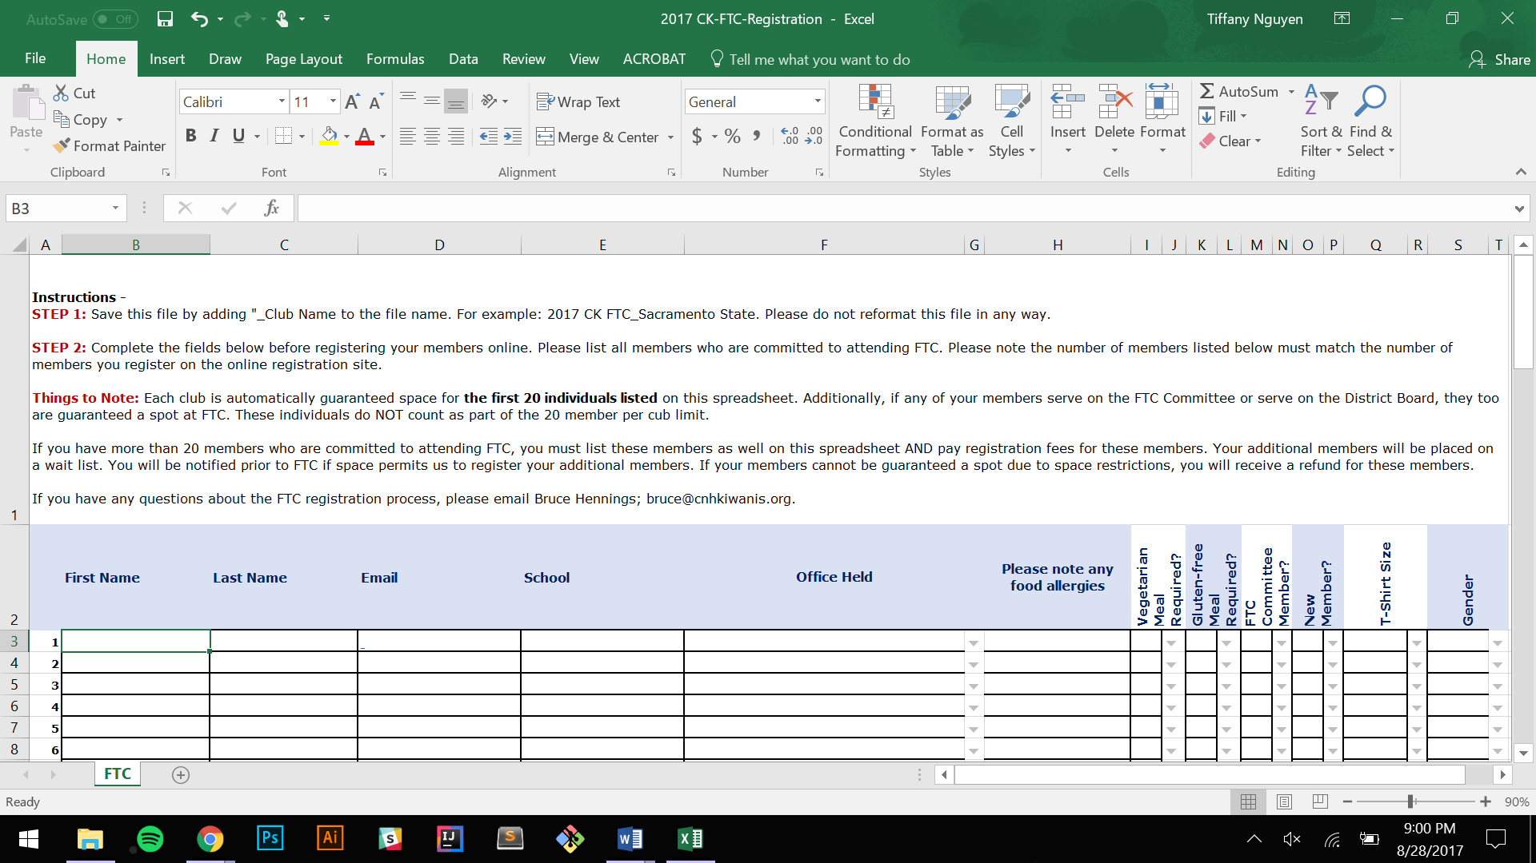

1. Read the instructions.
2. Fill out the gathered information for each member in the cells.
3. Save the Excel file as “2017 CKI FTC_Club Name”

* For example: 2017 CKI FTC_UC BERKELEY

**PART 3**:

Once you fill out the Excel spreadsheet and close it, read through the listed things that you should know one more time. They should be similar to the information included in this guide. When you are done, click “Next >>”.

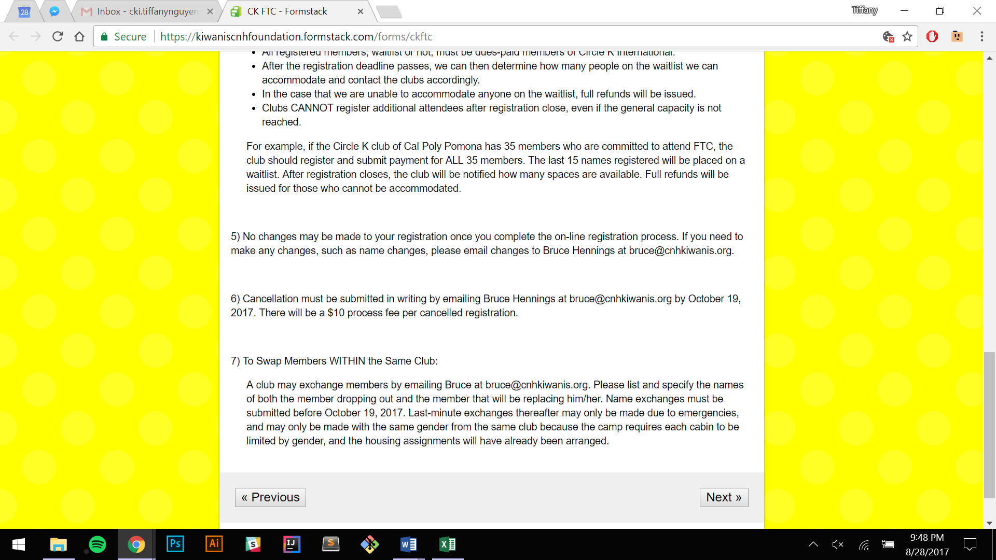

**PART 4**:

Read through this reminder regarding fees and deadlines and press “Next >>”.

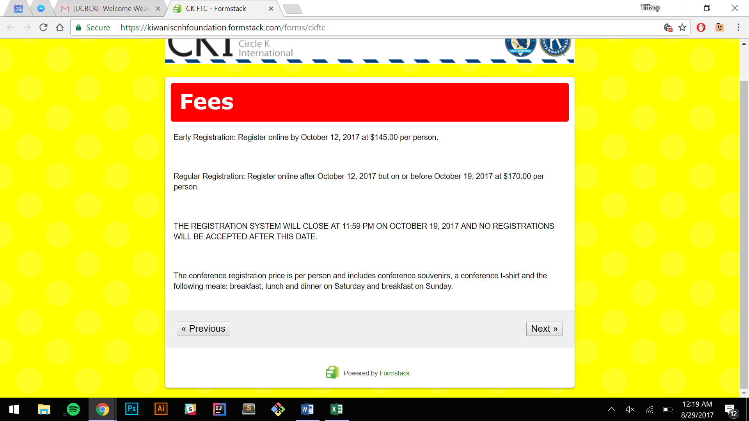

**PART 5**: You are now on the registration page!

1. For step 1, enter the information for your club’s primary contact.

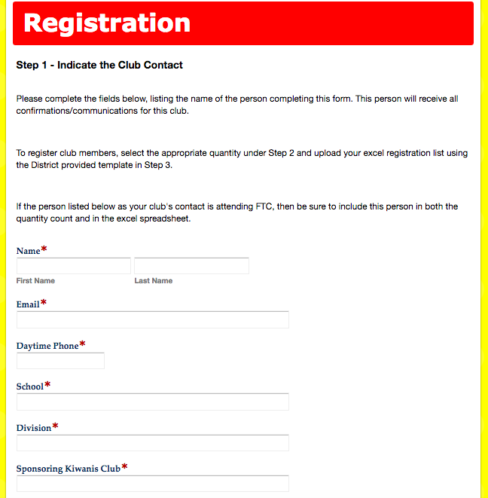

1. For step 2, indicate the number of members that are committed to attending FTC under either early registration or late registration.

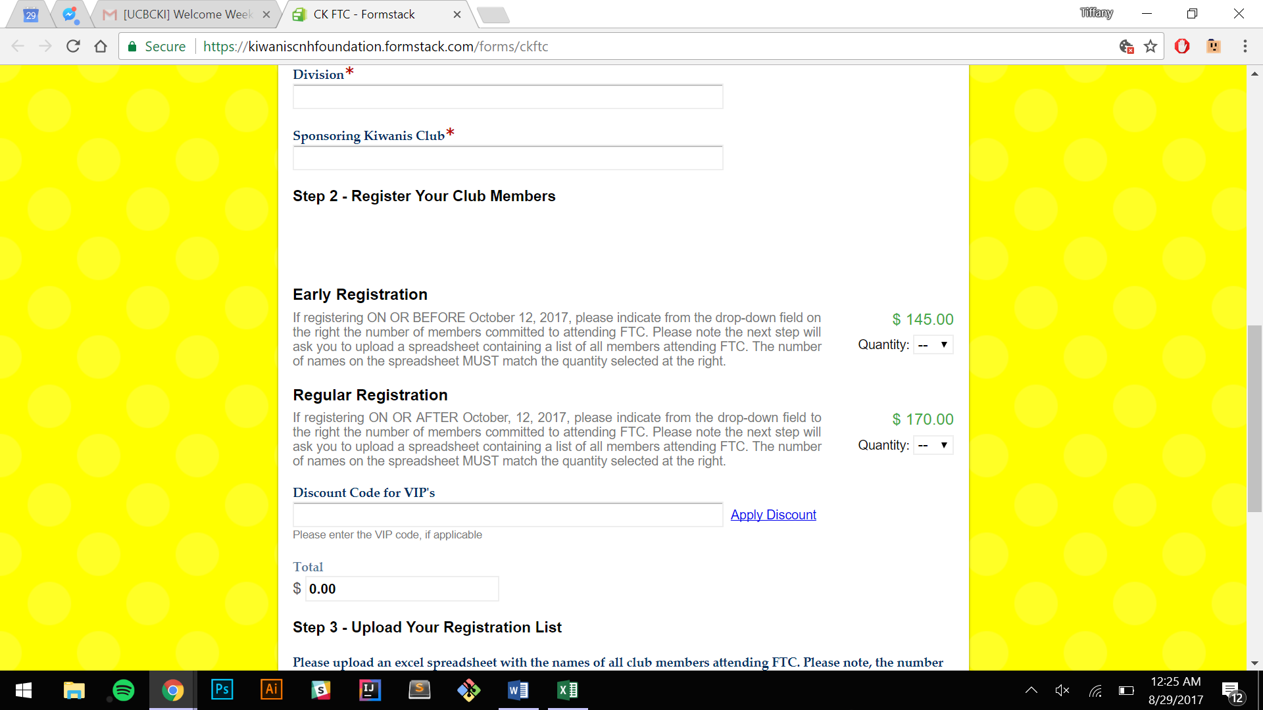

1. Scroll down to step 3 and upload the Excel spreadsheet with all the member’s information. Make sure the # of members on the Excel spreadsheet match the # you put for early or late registration.

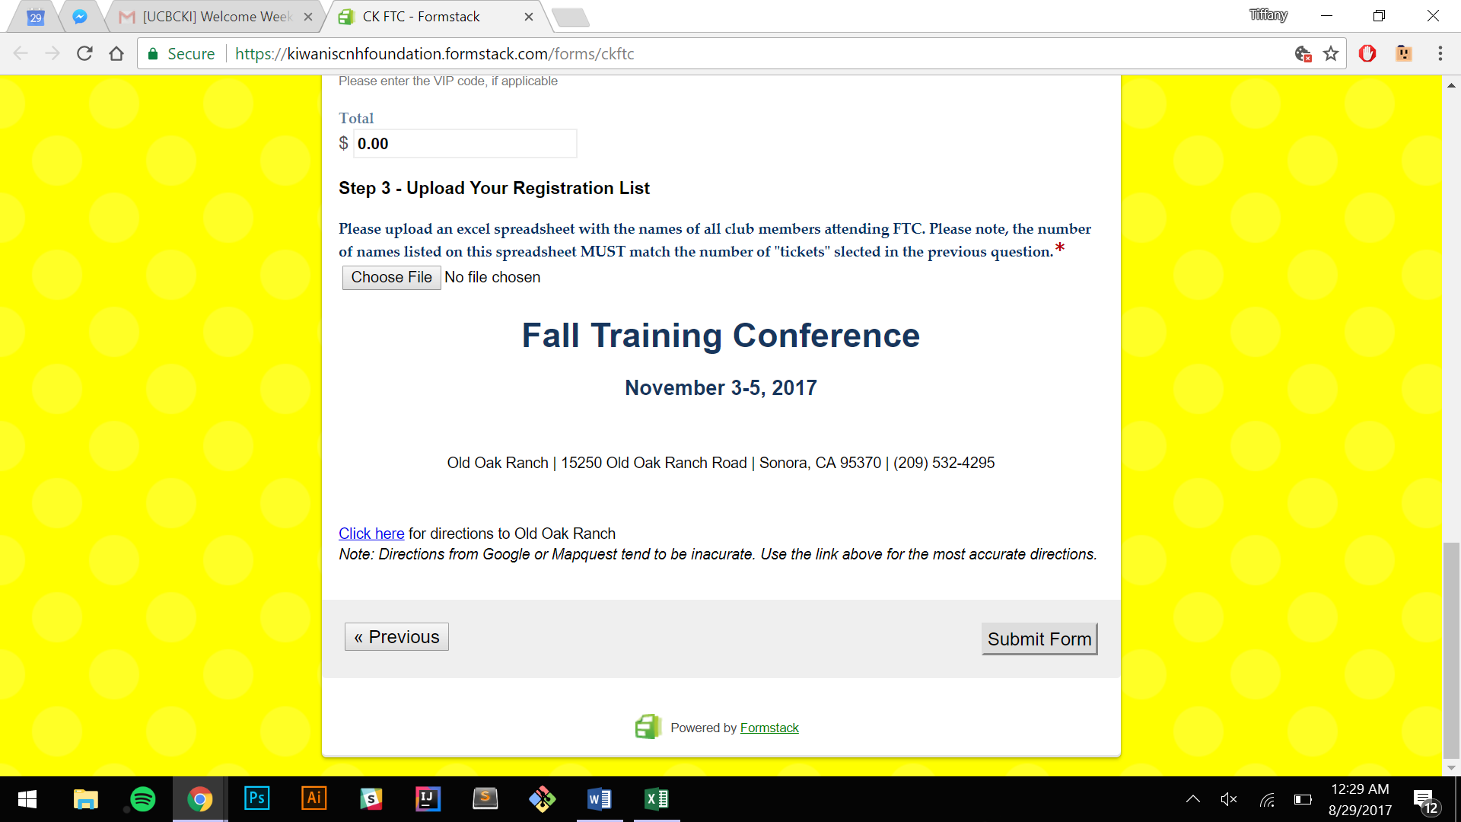

Review the information you inputted on the page, and then press “Submit Form”. You should receive an **email confirmation** shortly after. Be sure to print out the confirmation page that is sent to the email as you will need to mail it in.

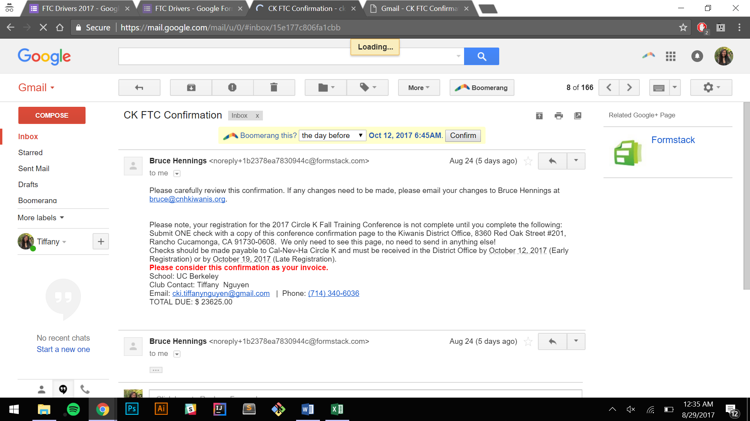

*This concludes the ONLINE portion of registration!*

**\*\*NOTE\*\*** If after you've submitted your club's registration you determine additional members would like to attend, please do NOT add to this list. Instead, complete a second list with only the names of the additional student(s).

**RESOURCES**

1. Fall Training Conference website: <http://ftc.cnhcirclek.org>

* Applications and forms for Campfire Skits & Talent Acts, DJ, Workshop Hosts,

Team Captain, Media Committee, Program Ads, Opening Slideshow

Submissions

* Driving directions to the campsite
* Waiver and Code of Conduct form
* SAA form
* Financial Assistance Guide
* Packing List

1. If you have any questions regarding the website or any questions regarding logistics of registration, you may email the following:

* Fall Training Conference Chair, Lindon Tran | [ftc@cnhcirclek.org](mailto:ftc@cnhcirclek.org)
* Registration Chair, Tiffany Nguyen | [ftc.register@gmail.com](mailto:ftc.register@gmail.com)
* Kiwanis SLP Director, Bruce Hennings | [bruce@cnhkiwanis.org](mailto:bruce@cnhkiwanis.org)

**FREQUENTLY ASKED QUESTIONS**

**What is a new member?**

A new member is a newly registered member from Winter 2017, Spring 2017, Summer 2017, or Fall 2017. Transferring students are eligible, but the first statement must apply.

**Are meals included in the price?**

Yes, attendees will be provided 3 meals on Saturday and breakfast on Sunday.

**What happens if I arrive late to FTC?**

Registration closes at 12AM on Friday, but will reopen and be available the next day (Saturday) from 6AM - 9AM. You will be able to find housing locations posted on the door to the lobby.

**How should I pack for FTC?**

Keep in mind that the weather in Sonora will be cold! The packing list can be found on the website.

**How many SAAs does my club need?**

Each club will be expected to register a minimum of 2 SAAs, plus an additional SAA for every 4 members that attend. Review the SAA form for more detailed information.

**When can my club sell our spirit items / t-shirts?**

Each club can sign up to sell merchandise during Saturday Night Activities! Contact the Registration Chair, Tiffany Nguyen, for more information.

**Do faculty/Kiwanis advisors need to register? If yes, how?**

Yes! Both advisors need to turn in waivers and code of conduct forms. They can either register with their Circle K club (preferred) or register on their own.

**CHECKLIST**

**What to send in to the district office**:

1. Confirmation page of online registration
2. Written check payable to Cal-Nev-Ha Circle K
3. Waiver form and Code of Conduct form for each attending member

**What to fill out before Fall Training Conference**:

1. SAA form (**October 13 for priority registration, October 20 for final registration**)
2. Ride arrangements Google form: <https://goo.gl/forms/iVf0FTB8tHIwOJEW2>, due **Tuesday, October 31, 2017**. Please have **one person** from your club fill this out!

**Arrival at Fall Training Conference**:

1. Head to the registration tables according to last name and check in. You will also receive a t-shirt and souvenirs at a separate table.
2. There will be a separate table for drivers to check in and receive their parking passes.

**DRIVER REMINDERS**

Please pass this information along to your club’s driver(s)!

1. Make sure all the drivers from your club are listed on the Google form. Once on site, the drivers will be able to check in at the drivers’ table and get a parking permit for their dashboards. They will receive it after registering.
2. Drivers should get proper rest both before and during the convention in order to drive to the site and back home safely.
3. Please park only where directed! Directions are posted on the FTC website to help guide drivers to the campsite.
4. The GPS is not a reliable source so please make sure to use the posted directions along with a set of printed directions from Google maps if needed. There will be posters to help guide you up the mountain.
5. Drivers who have arrived safely will have their names put into a raffle for a gas gift card.
6. Make sure at least one passenger (preferably front seat) is awake during the car ride!
7. **DRIVE SAFELY!!!!!!!!!**

***THANK YOU for using this resource to help register your club for Fall Training Conference!***

If you need to contact the Fall Training Conference chair or any one of the FTC committee members, please feel free to email us using the contact information provided below.

**Contacts:**

Fall Training Conference Chair, Lindon Tran | [ftc@cnhcirclek.org](mailto:ftc@cnhcirclek.org)

Executive Assistant, Edward Huang| [ftc.execassistant@gmail.com](mailto:ftc.execassistant@gmail.com)

Executive Assistant, Allen Pham| [ftc.execassistant@gmail.com](mailto:ftc.execassistant@gmail.com)

AV & Technology, Jonathan Chu | [avtech.ftc@gmail.com](mailto:avtech.ftc@gmail.com)

Campfire, Cecilia Nguyen | [ftc.campfireskits@gmail.com](mailto:ftc.campfireskits@gmail.com)

Decorations (Backdrop), Olivia Chang | [ftc.decorations@gmail.com](mailto:ftc.decorations@gmail.com)

Decorations (Centerpieces), Alyssa Quy| [ftc.decorations@gmail.com](mailto:ftc.decorations@gmail.com)

Entertainment & Dining, Christina Chu | [ftc.entertainments@gmail.com](mailto:ftc.entertainments@gmail.com)

Graphics, Sandy Tsan | [ftc.graphics@gmail.com](mailto:ftc.graphics@gmail.com)

Media, Jennifer Nguyen | [ftc.mediachair@gmail.com](mailto:ftc.mediachair@gmail.com)

Program, Darin Ngo | [ftc.programs@gmail.com](mailto:ftc.programs@gmail.com)

Registration, Tiffany Nguyen | [ftc.register@gmail.com](mailto:ftc.register@gmail.com)

SAA, Josephine Molina | [ftc.saachair@gmail.com](mailto:ftc.saachair@gmail.com)

Team Activities, Nick Stringfellow | [ftc.teamactivities@gmail.com](mailto:ftc.teamactivities@gmail.com)

Workshops, Alondra Covarrubias | [ftc.workshops@gmail.com](mailto:ftc.workshops@gmail.com)

Workshops, Andrea Famularcano | [ftc.workshops@gmail.com](mailto:ftc.workshops@gmail.com)

